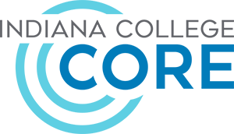
Indiana College Core
(30 credit hours with minimums from each section)

Written/Speaking Minimum 6 credits
- Composition - ENGL111 (3 credits) - REQUIRED
- Speech - COMM101 (3 credits) - REQUIRED
- Rhetoric & Argument – ENGL215 (3 credits) - Optional
- Interpersonal Comm. – COMM 102 (3 credits) – Optional _____

Math Minimum 3 credits
- Finite - MATH135 (3 credits)
- Pre-Calculus - MATH136 (3 credits)
- Pre-Calculus - MATH137 (3 credits)
- Calculus - MATH211 (4 credits)
- AP Statistics* - MATH200 (3 credits)

Science Minimum 3 credits
- Biology - BIOL101 (3 credits)
- AP Chemistry* - CHEM101 (3credits)
- Physical Science – SCIN111 (3 credits)
- Earth Science - SCIN100 (4 credits)

Social/Behavioral Minimum 3 credits
- Psychology - PSYC101 (3 credits)
- Government - POLS101 (3 credits)
- Abnormal Psychology – PSYC205 (3 credits)

Humanistic/Art Minimum 3 credits
- Intro. to Literature – ENGL 206* (3 credits)
- Intro. to Philosophy – PHIL 101 (3 credits)
- Ethics – PHIL 102 (3 credits)
- AP Spanish* - SPAN 201 & SPAN 202 (6 credits)
* If a student scores a 3, 4, or 5 on AP exams then they will earn dual credit for the noted courses. Steps will need to be taken to send exam scores to Ivy Tech.

